Mallu Sravana Sandhya Assessment-11 15/12/2023

Set-it is a collection of different datatypes in unordered form with is mutable

Frozen set-it is similar to set but it is immutable it performs all methods of sets

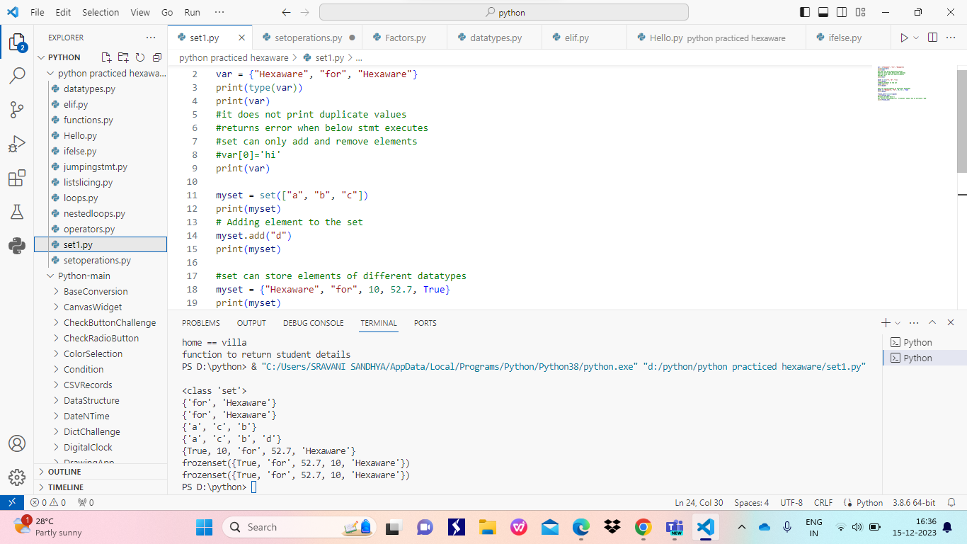

SET OPERATIONS

Add()--adds an element to the set

Remove()-removes element from set

Discard()-drops the element from set

Copy()-it provides a shallow copy

Union-it combine the elements from 2 sets and remove duplicate elements

Intersection-returns common values from two sets

Difference-returns the elements present only in a not in b

Clear()-removes all elements from the set

Pop()-it takes a random element from set

Update()- it is also to add elements to set

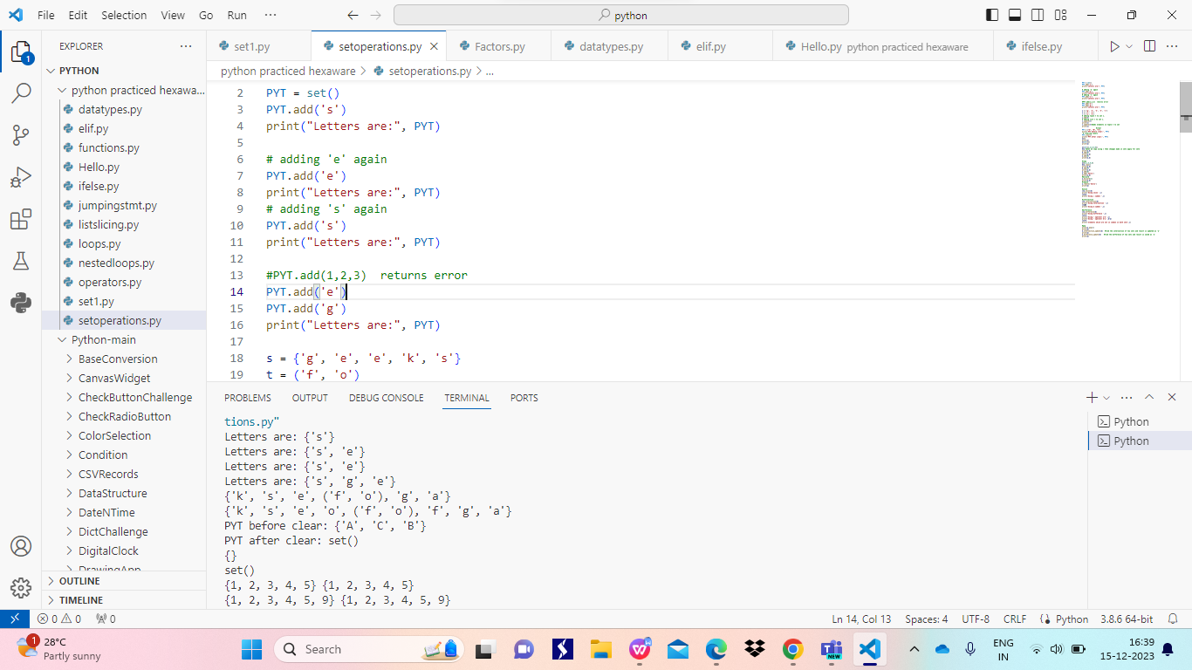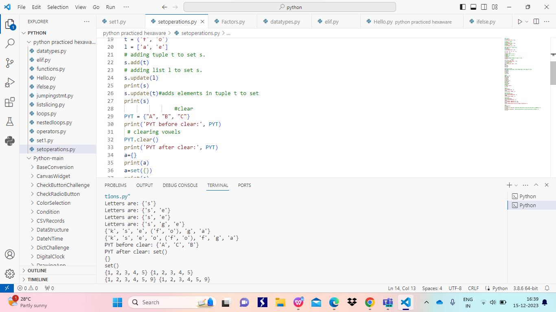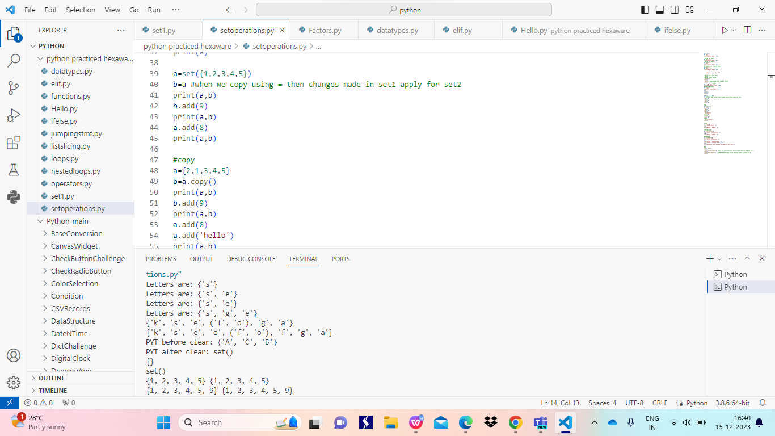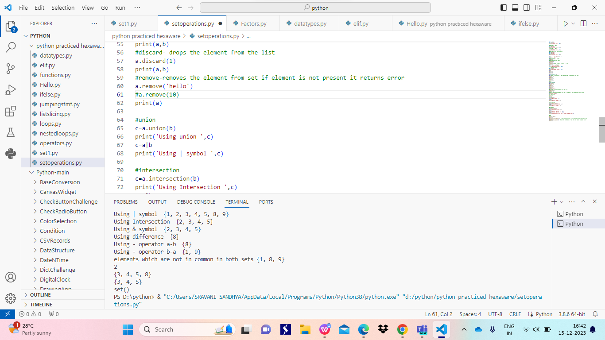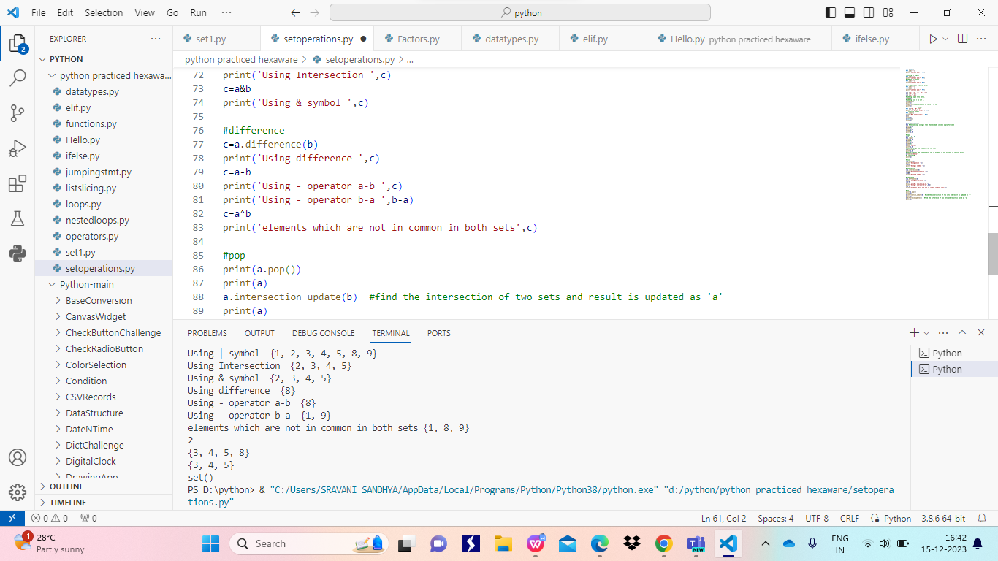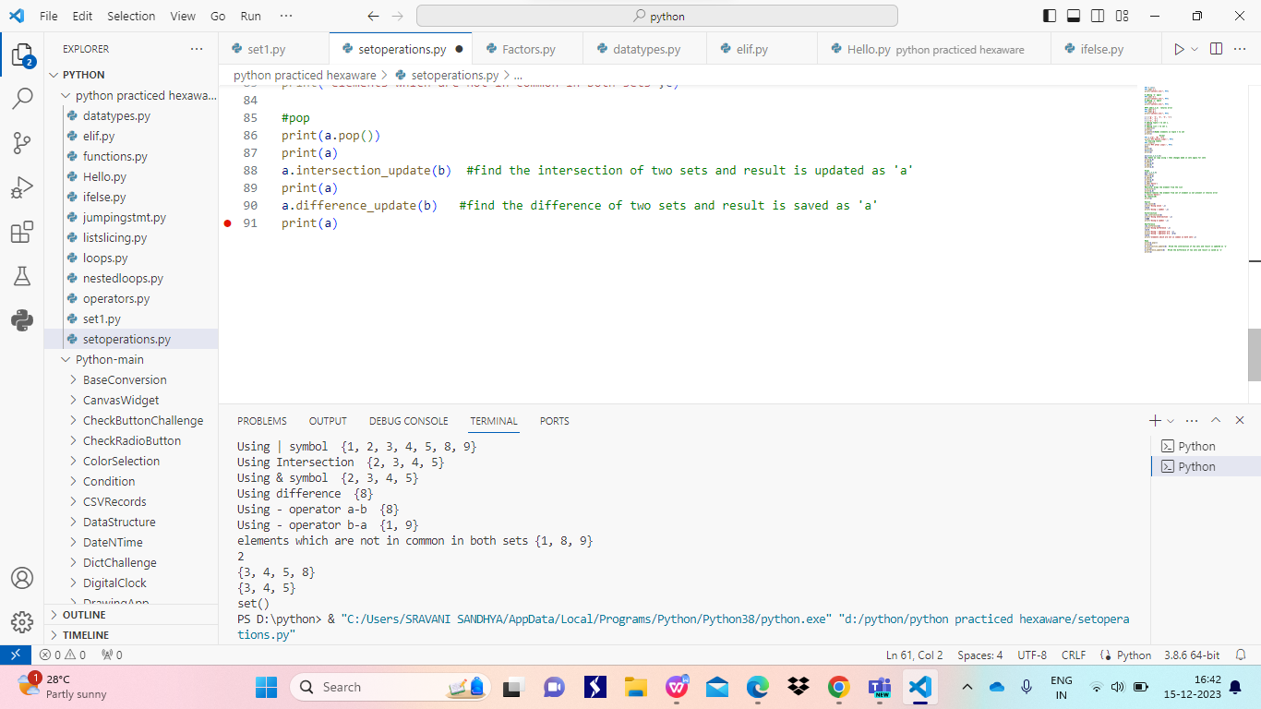

**Functions**

It is used to some block of code that can be repeatedly used in a program

It helps for code reusability and readability

It can be used in the program with the help of function calls

